Name _______________ Group _______________

**Part 1 Listening**

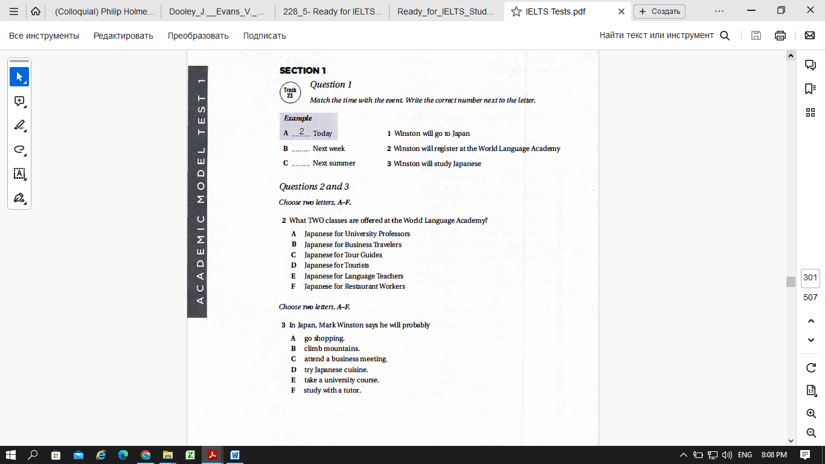

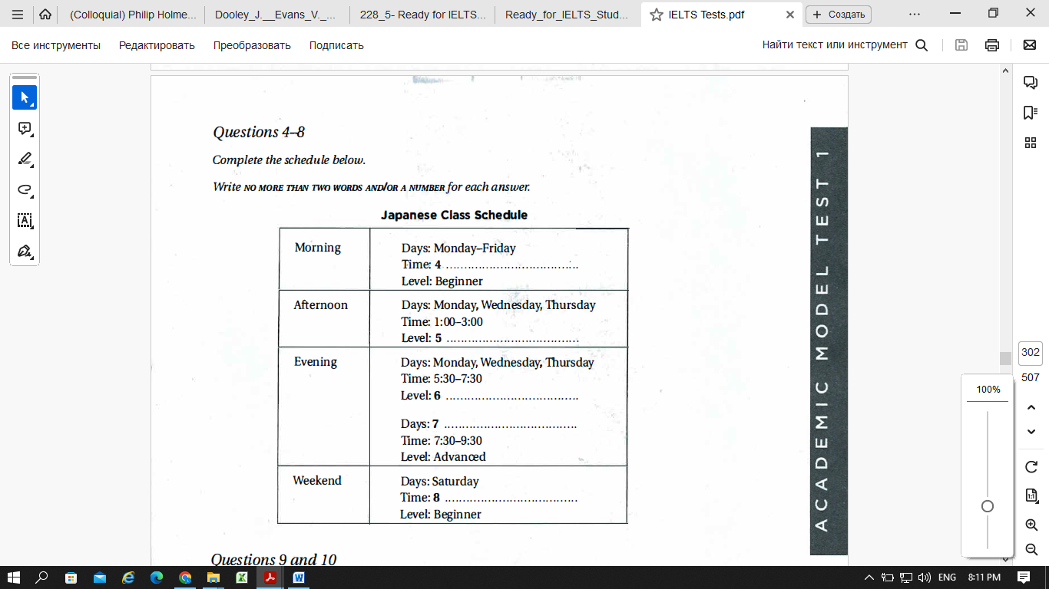

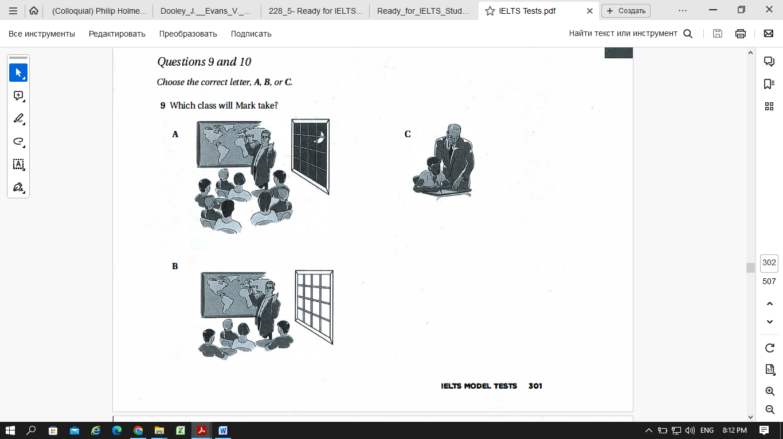

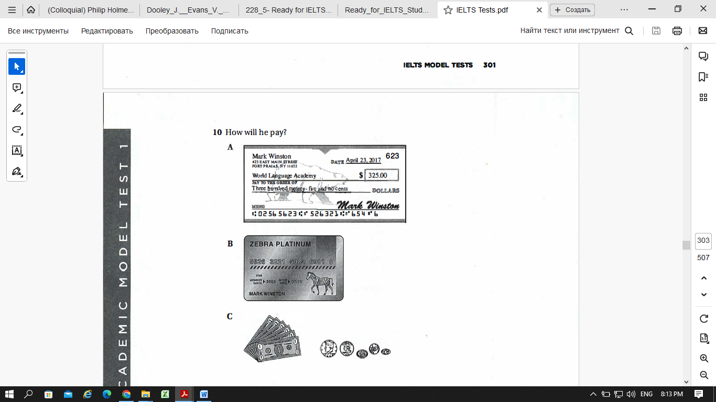

**Part 2 Reading**

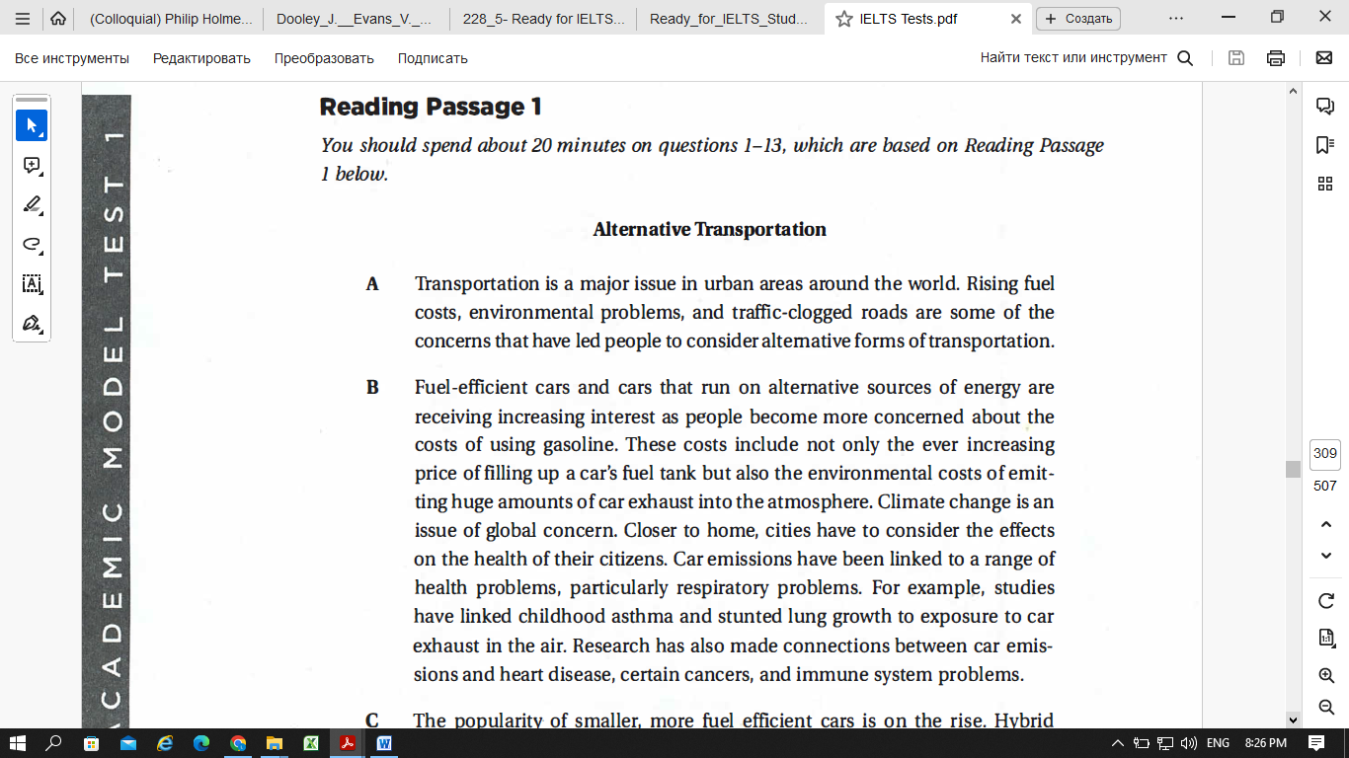

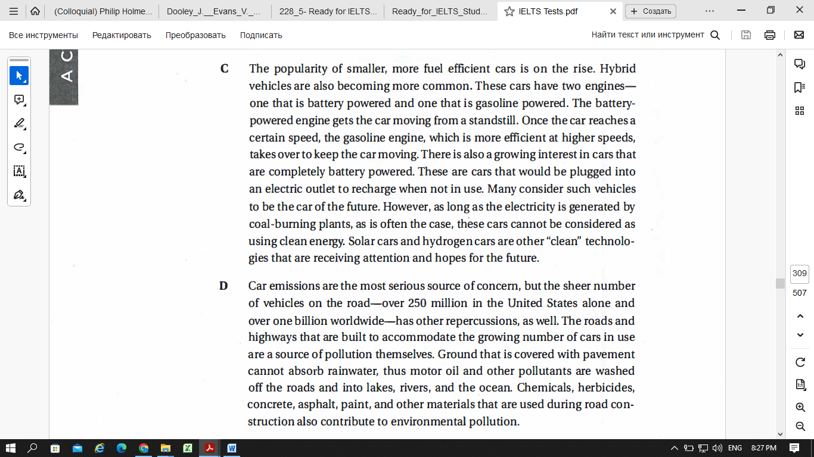

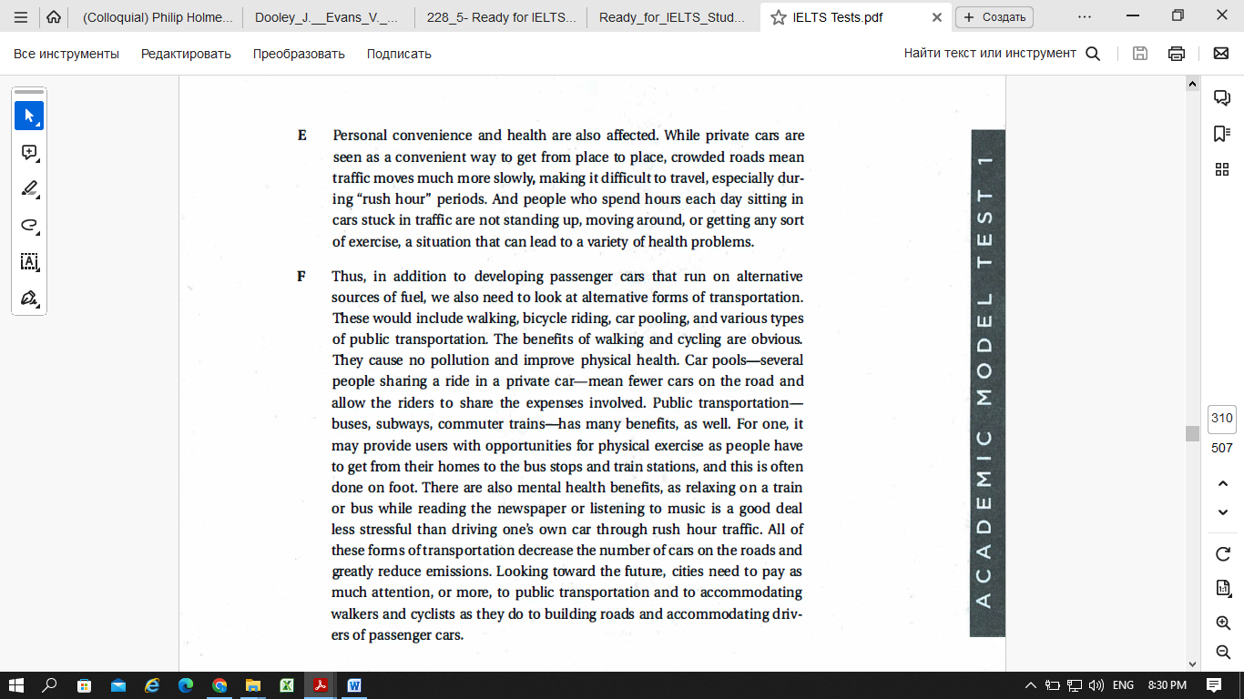

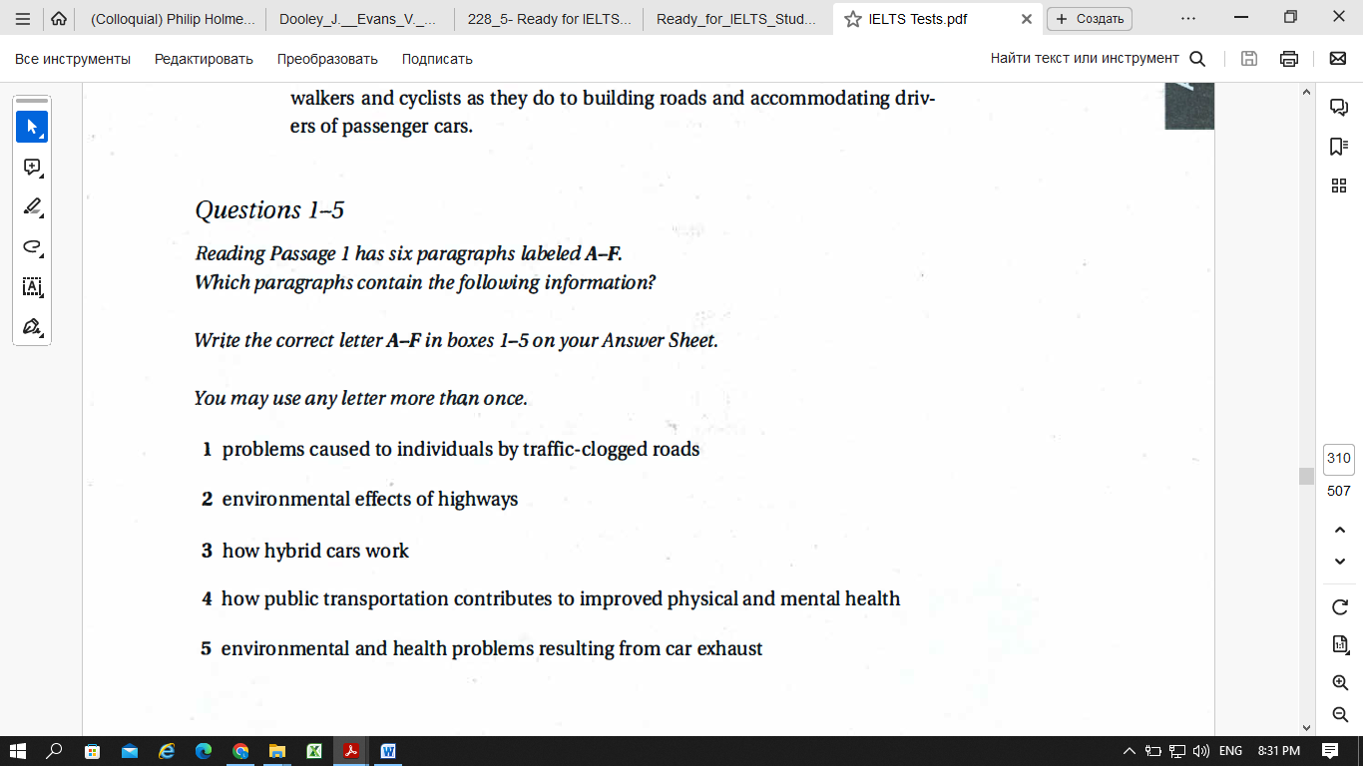

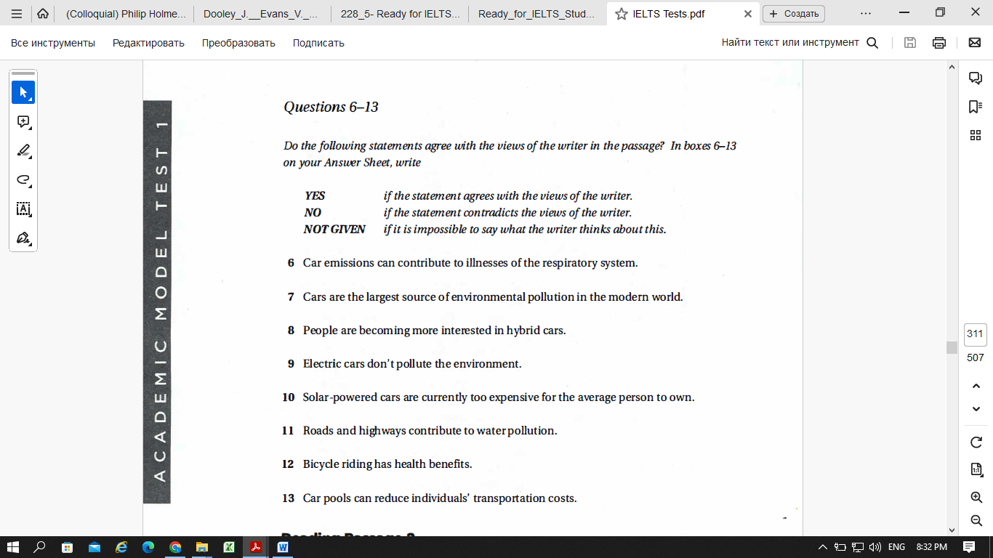

**Part 3 Vocabulary**

I Complete the sentences using an appropriate adjective.

1. I think I’m really _______. I always try to think about other people first.
2. They are very _______. They always do their homework and check the answers before giving it to the teacher.
3. He is always _______. He will go anywhere, do anything and eat anything!
4. My mother is very _____. She has exhibited her work in a local gallery.
5. Thank you for being so _____. It really helped me at a difficult time.

II Put the words in brackets into the correct form.

1. I loathe ______ (do) housework.
2. He can’t bear _____ (be) bored.
3. She prefers _____ (play) computer games than ______ (socialize).
4. I know we discussed going next week but, to be honest, I’d rather _____ (go) this weekend.
5. I’d prefer ____ (not study) but I don’t have much choice.

III Choose the best phrase a- h to describe each graph 11-16 below.

1. Fell slightly and then levelled off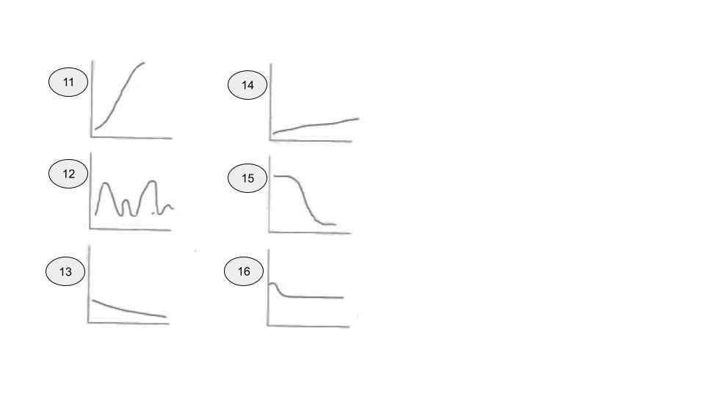
2. Remained flat
3. Plummeted
4. Rose gradually
5. Fell gradually
6. Soared
7. Dipped
8. Fluctuated

IV Answer the questions

17. What is the motherboard and what does it contain?

18. What is the CPU and what is its function?

19. What are solid state drives and how do they differ from magnetic platter hard drives?

20. What is a heat sink and why is it important?

21. What is RAM? Can you store files in RAM? Why?

22. What is a hard drive and what is its function?

**Part 4 Grammar**

I Put the verbs in brackets into the present simple or the present continuous.

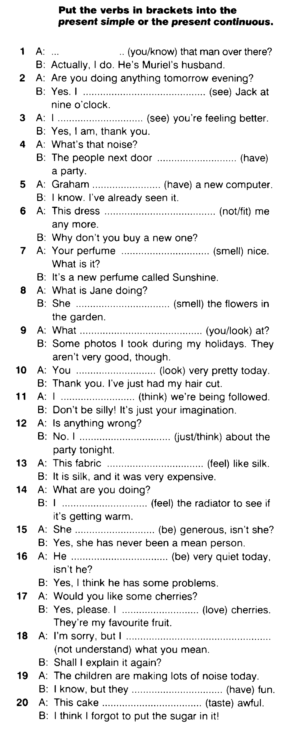

II Complete the sentences. Use the past simple of the verbs in brackets.

21. I _____ a cycle ride for charity last year. (do)

22. We _____ from the most northerly point of Ireland to the most southerly. (go)

23. It _____ us seven days to cover about 670 kilometres. (take)

24. We ______ some beautiful lakes and rivers. (see)

25. I ______ I had so many mucles that could hurt! (not know)